
CS673 Software Engineering
Team 1 - Bariatric-Pathway
Software Design Document

Team Member | Role(s) | Signature | Date
Fatimah Hassan | Security Lead and Configuration Co-Lead | Fatimah Hassan | 5/23/2026
Shaima Nimeri | Team Lead  Design and Implementation Lead  Requirement lead | Shaima Nimeri | 5/24/2026
Kai Fernandes | Team Co-Lead  Configuration Co-Lead | K. Fernandes | 5/24/2026
Jianing Li | Requirement Co-Lead | Jianing Li | 5/25/2026
Kolya Gavlishin | QA Lead Design and Implementation Co-LEad | Kolya Gavlishin | 5/25/26

Revision history
Version | Author | Date | Change
1.0 | Fatimah, Shaima, Kolya, Jianing, Kai | 05/24 | Initial document creation

● Introduction
● Software Architecture
● Class Diagram
● UI Design (if applicable)
● Database Design (if applicable)
● Security Design
● Business Logic and/or Key Algorithms
● Design Patterns
● Rest APIs
● Any Additional Topics you would like to include.
● AI usage Log
● References
● Glossary

Introduction - Kai
BariatricPath is a web-based patient portal designed to streamline the bariatric surgery clearance process. The system serves three user roles — patients, coordinators, and program directors — each with their own dashboard and permissions. The core problem it solves is the lack of clarity patients experience while navigating the pre-surgery evaluation pathway; the portal gives them real-time visibility into their status and checklist progress without needing to contact their coordinator directly.
The system is built as a three-tier React/Node.js/PostgreSQL application, using Firebase Authentication for identity management, Prisma as the ORM, and Docker Compose for local development.
Design Goals
- Security — Patient data is sensitive, so the system uses Firebase Auth (scrypt-hashed passwords, signed JWTs), server-side token verification on every request, role-based access control, and an append-only audit log. The STRIDE threat model was applied to the login flow.
- Usability — The UI is intentionally simple and clinical: Google sign-in, clear error messages via toast notifications, and role-based routing that lands each user directly on the correct dashboard. The goal is to reduce friction for patients who may not be technically savvy.
- Maintainability — A closed-layered backend (Routes → Middleware → Services → Prisma) keeps concerns separated and testable, which is important for a five-person student team working in short iterations.

Software Architecture - Shaima|Fatimah

2.1 Architectural Style
BariatricPath uses a three-tier client-server architecture with a layered backend. The three physical tiers are:
  - Client tier - a React single-page application (SPA) running in the user’s browser.
  - Application tier - a Node.js + Express REST API, running in a Docker container.
  - 1. Data and identity tier — PostgreSQL (in a Docker container) for application data, and Firebase Authentication (managed cloud service) for identity.

Inside the application tier, the backend is organized in a closed-layered pattern: a request flows through Routes — Middleware — Services –Prisma(Repository). Each layer talks only to its immediate neighbours, which keeps the system easy to reason about and easy to test.
Why three tiers and not microservices? At the scale of this academic project and team size (five members, seven weeks), a single well-organized backend is dramatically simpler to develop, test, and reason about than a microservices mesh. The one exception, by design, is the AI service introduced in Iteration 2 — see Section 2.4.

2.2 System Architecture Diagram
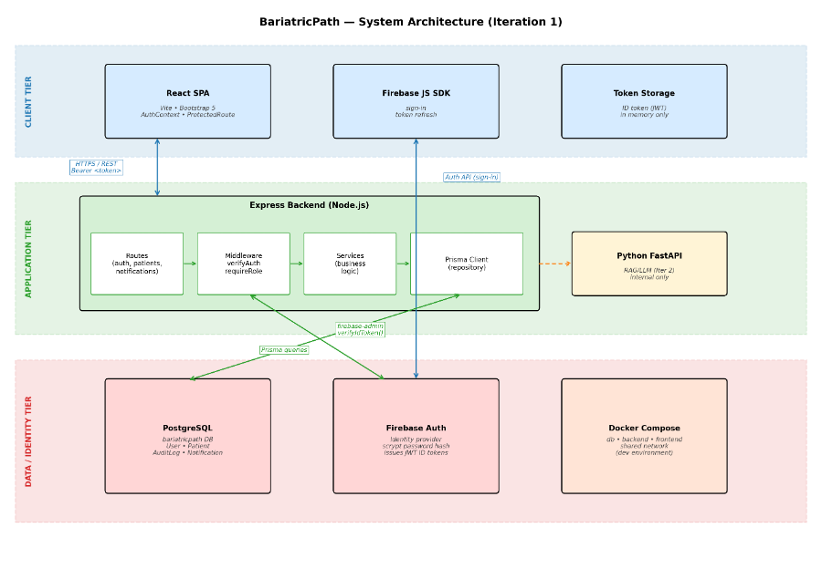
Figure 1. BariatricPath system architecture — three-tier layout showing the client tier (React SPA, Firebase JS SDK, in-memory token storage), the application tier (Express backend with internal layers: Routes – Middleware – Services – Prisma Client; FastAPI to be added in Iteration 2), and the data/identity tier (PostgreSQL, Firebase Auth, Docker Compose).

2.3 Component Responsibilities

Component | Responsibility | Tier
React SPA | Renders all user interface, handles client-side routing, manages authentication state via AuthContext, gates routes via ProtectedRoute. | Client
Firebase JS SDK | Performs sign-in (email/password and Google), refreshes the ID token automatically before expiry. | Client
Token storage | Holds the Firebase ID token in JavaScript memory (React context). Not persisted to localStorage or cookies. | Client
Express Routes | Parses HTTP requests, validates inputs with express-validator, and routes to the correct controller logic. | Application
Auth middleware (verifyAuth) | Verifies the Firebase ID token on every protected request using firebase-admin.verifyIdToken(). | Application
Role middleware (requireRole) | Enforces role-based access control (PATIENT, COORDINATOR, PROGRAM_DIRECTOR). | Application
Services | Encapsulate business logic such as patient status transitions and audit log writes. Stateless. (Being formalized in Iteration 1.) | Application
Prisma Client | Repository layer — issues type-safe SQL queries to PostgreSQL based on the schema in server/prisma/schema.prisma. | Application
PostgreSQL | Persistent storage for User, Patient, AuditLog, and Notification entities. A dedicated database user (bariatric_user) is used in development. | Data
Firebase Auth | External identity provider. Hashes passwords (scrypt), issues ID tokens (signed JWTs with ~1-hour expiry), and supports federated Google sign-in. | Identity
Docker Compose | Orchestrates db, backend, and frontend containers on a shared internal network for the development environment. | Infrastructure

2.4 Frameworks and External Services

Layer | Framework / Service | Rationale
Frontend | React 18 + Vite + Bootstrap 5 | React is the de-facto SPA framework; Vite gives instant hot reload; Bootstrap provides a consistent design system without bespoke CSS.
Backend | Node.js 20 + Express 4 | Lightweight, well-understood, and the team is comfortable with JavaScript end-to-end.
ORM | Prisma 5 | Type-safe queries; auto-generates a typed client from the schema; migrations are first-class.
Database | PostgreSQL 15 | Industry-standard relational database with strong transactional guarantees; well-suited to the relational data model.
Identity | Firebase Authentication | Mature, free for our usage tier, supports email/password and Google federation, handles secure password hashing (scrypt), and issues JWT ID tokens we can verify server-side.
AI (Iter 2) | Python FastAPI + LangChain | Python has the more mature LangChain ecosystem. We will run it as a separate microservice on the internal Docker network.
Containers | Docker + Docker Compose | Consistent development environment for the whole team; trivial path to deployment in Iteration 2/3.
Testing | Jest, Supertest, React Testing Library | Standard, widely-supported, well-documented for the chosen stack.

2.5 Inter-Component Communication
• Client ↔ Backend: HTTPS REST. All authenticated requests carry an Authorization: Bearer <token> header containing the Firebase ID token.
• Backend ↔ Firebase Auth: the backend uses firebase-admin to verify ID tokens server-side. It does not issue or manage tokens — Firebase does that.
• Backend ↔ PostgreSQL: Prisma Client over a standard PostgreSQL connection on the internal Docker network.
• Backend ↔ AI Service (Iter 2): will be implemented in iteration 2 through internal HTTP only. The FastAPI container will not be exposed to the public internet; will be reachable only from the Express backend on the shared Docker network.

2.6 Deployment View
Development: every team member runs the system locally via Docker Compose, which brings up three containers: db, backend, and frontend. Each developer also runs their own local Firebase project for testing, while the shared Firebase project is used for integration testing.
Production (planned for Iteration 2/3): the system will be deployed to Digital Ocean, with the same three-container layout, plus the FastAPI AI container, behind a managed load balancer with TLS termination.

Class Diagram - Kai

User - The User class is the central identity entity in BariatricPath. It represents every person who has an account in the system, regardless of role. Each User stores a firebaseUid which is the unique identifier issued by Firebase Authentication and acts as the bridge between the external identity provider and the local database record. The role field determines which dashboard the user is routed to upon login and which API endpoints they are permitted to call. A User record is created transactionally alongside a Firebase account during registration, meaning both must succeed or both are rolled back. The User class has a composition relationship with Patient, AuditLog, and Notification, meaning those records cannot exist without an associated User.
Patient - The Patient class represents the clinical record for a bariatric surgery candidate. It is the central data entity in the system and acts as the single source of truth for a patient's evaluation progress. Each Patient is linked to exactly one User through the userId foreign key. The class stores the patient's physical measurements (bmi, height, weight) used for eligibility screening, as well as a collection of clearance fields (surgeonClearance, psychClearance, dietitianClearance) that track specialist sign-offs. The surgeryClearedFlag is set to true when all required clearances are complete, triggering the "Surgery Cleared" banner on the patient portal. The status and insuranceStatus fields capture the patient's current position in the bariatric evaluation pathway. The Patient class has a composition relationship with both AuditLog and Notification, as those records are always created in the context of a specific patient record.
AuditLog - The AuditLog class provides an immutable, append-only record of every change made to a patient's data. Each entry captures the userId of the actor who made the change, the patientId of the affected record, the column that was modified, and both the oldValue and newValue so that the full history of any field can be reconstructed. The timestamp is always server-generated to prevent client-side manipulation. By application convention the audit log is never updated or deleted through the application surface — only created. This satisfies the accountability pillar of the system's IAAA security model and provides a complete audit trail for coordinators and program directors. AuditLog has no direct relationship to Notification; both are independently triggered by PatientService when a field update occurs.
Notification - The Notification class stores user-facing alerts that are generated whenever a coordinator updates a patient's checklist. Each record holds the userId of the recipient (always the patient), the patientId of the record that changed, a human-readable message describing the update, and a read flag that tracks whether the patient has seen the notification. Unlike AuditLog, which is a compliance record, Notification is purely a UX concern — it exists to keep patients informed without requiring them to call their coordinator. Notifications are created by NotificationService and are independent of AuditLog entries, even though both are produced by the same update event.
Role (enumeration) - Role is a Prisma enum that defines the three permitted user types in the system: PATIENT, COORDINATOR, and PROGRAM_DIRECTOR. It is referenced as a field type on User and as a parameter type in the requireRole middleware. Defining roles as an enum rather than a free-text string provides type safety at the ORM level — it is impossible to assign an invalid role through the application. Adding a new role would require a database migration, which is an acceptable trade-off since roles change rarely.
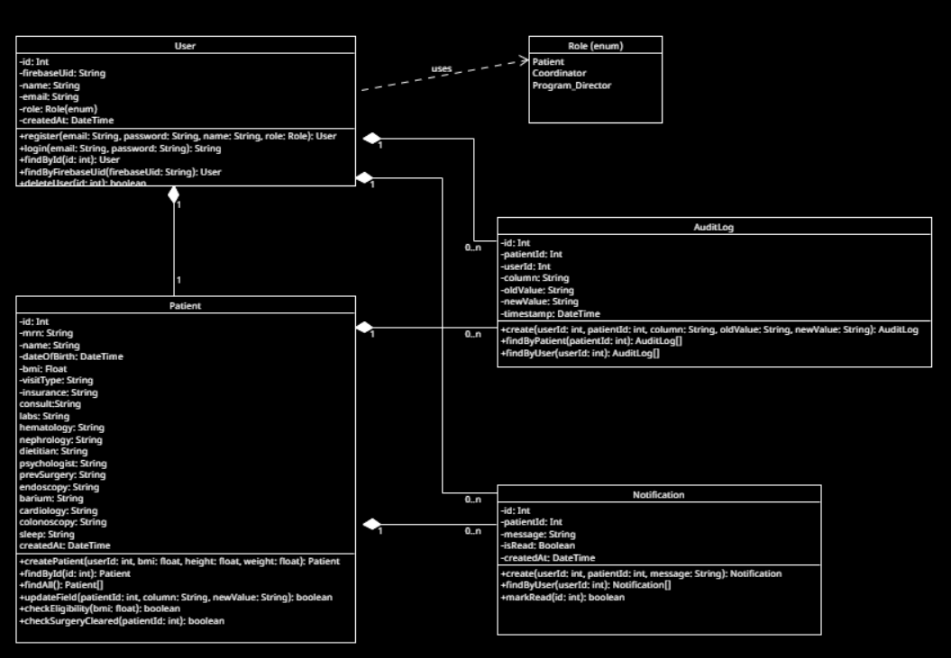

Package: server/middleware
This package contains three middleware files that form the security and logging pipeline for every API request. All three run before any route handler executes.
verifyAuth (verifyAuth.js) - verifyAuth is the authentication gate for every protected API endpoint. It runs first in the middleware chain and is responsible for proving that the caller is who they claim to be. It extracts the Firebase ID token from the Authorization: Bearer header, calls firebase-admin.auth().verifyIdToken() to validate the JWT signature, expiry, audience, and issuer against Google's public keys, and then looks up the matching local User record by firebaseUid. On success it attaches the resolved User object to the request for downstream handlers. On any failure — missing header, malformed token, expired token, or no matching local user — it returns 401 Unauthorized immediately and the request goes no further. It has a «uses» dependency on AuthService (routes/auth.js) to perform the local user lookup. Every protected route in the system runs verifyAuth before any other middleware.

requireRole (auth.js) - requireRole enforces role-based access control at the route level. It is a factory function — called with an array of permitted Role values, it returns an Express middleware function that checks the authenticated user's role against that list. If the role does not match it immediately returns 403 Forbidden. It depends on verifyAuth having already run and attached the user to the request; it never authenticates independently. It has a «uses» dependency on PatientService since patient routes are the primary endpoints it protects. On the client side ProtectedRoute performs an equivalent check for UX purposes, but requireRole on the server is the true security boundary. Note: this class lives in middleware/auth.js — distinct from routes/auth.js which handles registration and login.

auditLogger (auditLogger.js) - auditLogger is the audit logging middleware responsible for recording every state-changing operation on patient records. It intercepts requests after authentication and authorization have passed and, following a successful response, writes an AuditLog entry capturing the actor's userId, the affected patientId, the column changed, and the oldValue and newValue. It uses a database transaction via writeTransaction() to ensure the audit write and the patient update always succeed or fail together — a partial write where the patient record changes but no audit entry is created is never permitted. It has a «calls» dependency on PatientService to retrieve the before-state of a field prior to the update. This module reflects the Iteration 2 refactor described in the SDD, where inline audit writes in route handlers were centralized into a dedicated middleware.

Package: server/routes

This package contains the three route handler files that implement the application's business logic. Each file maps to a REST resource and exposes the endpoints for that resource.

AuthService (auth.js) - AuthService handles all authentication and user registration logic. Its most critical responsibility is the transactional registration flow: it calls firebase-admin.auth().createUser() to create the Firebase identity record, then creates the matching local User row in PostgreSQL within a Prisma transaction. If the database write fails, rollbackFirebaseUser() is called to delete the Firebase record and restore a consistent state, ensuring a user can never sign in without a local profile. The login() method verifies a Firebase ID token and returns the resolved user's role so the client can route to the correct dashboard. verifyToken() wraps the firebase-admin call and is used by verifyAuth middleware to resolve the local user from a token. Note: this file is routes/auth.js — distinct from middleware/auth.js which contains requireRole.

PatientService (patients.js) - PatientService is the core business logic layer of BariatricPath. It manages all patient record operations and is the most depended-upon class in the system. The updateField() method is the most important — it updates a single column on a patient record and triggers both auditLogger middleware and NotificationService to ensure the change is logged and the patient is alerted. checkEligibility() enforces the BMI threshold rule, blocking patients with a BMI below 27 from completing registration. checkSurgeryCleared() evaluates all clearance fields on a patient record and sets the surgeryClearedFlag when all are true, which triggers the Surgery Cleared banner on the patient portal. getPatients() returns the full patient list used by the coordinator and director dashboards. It holds a dependency on PrismaClient as its repository layer and has «calls» relationships to both auditLogger and NotificationService.
NotificationService (notifications.js) - NotificationService manages patient-facing notifications. When PatientService updates a patient field it calls notify() which creates a new Notification record for the affected patient with a human-readable message describing the change. getUnread() retrieves all unread notifications for a given user and is polled by the patient portal to populate the notification badge. markAllRead() clears the unread state when the patient opens their notification panel. NotificationService operates entirely independently of auditLogger — both are triggered by the same update event in PatientService but neither is aware of the other, keeping their concerns cleanly separated.

Package: client/src

This package contains the two client-side classes responsible for authentication state management and route protection across the React application.

AuthContext (context/) - AuthContext is a React context that holds the global authentication state for the entire client application. It stores the currently signed-in User object and the Firebase ID token in JavaScript memory only — never in localStorage or cookies — to eliminate the risk of XSS token theft. signIn() calls the Firebase JS SDK, receives the ID token, and stores it in the context so every component in the application can access it without prop drilling. signOut() calls firebase.auth().signOut(), clears all stored state, and redirects to /login. Because the token lives only in memory it is lost on a full page reload, requiring the user to sign in again — an accepted trade-off in a clinical context where persistent sessions carry greater risk than the inconvenience of re-authentication.

ProtectedRoute / roleRedirect (utils/) - ProtectedRoute is a React wrapper component that guards every authenticated page. It reads the current user and token from AuthContext — which is why it has an aggregation relationship with AuthContext (it uses it but does not own it) — and checks two conditions before rendering its children: that the user is authenticated, and that the user's role matches the requiredRole prop. If either check fails the user is redirected to /login. The companion utility roleRedirect runs immediately after a successful sign-in and programmatically navigates the user to /patient, /coordinator, or /director based on their role. Together these two utilities ensure users always land on the correct page and can never manually navigate to a page above their permission level on the client side, though requireRole middleware on the server remains the authoritative security boundary.
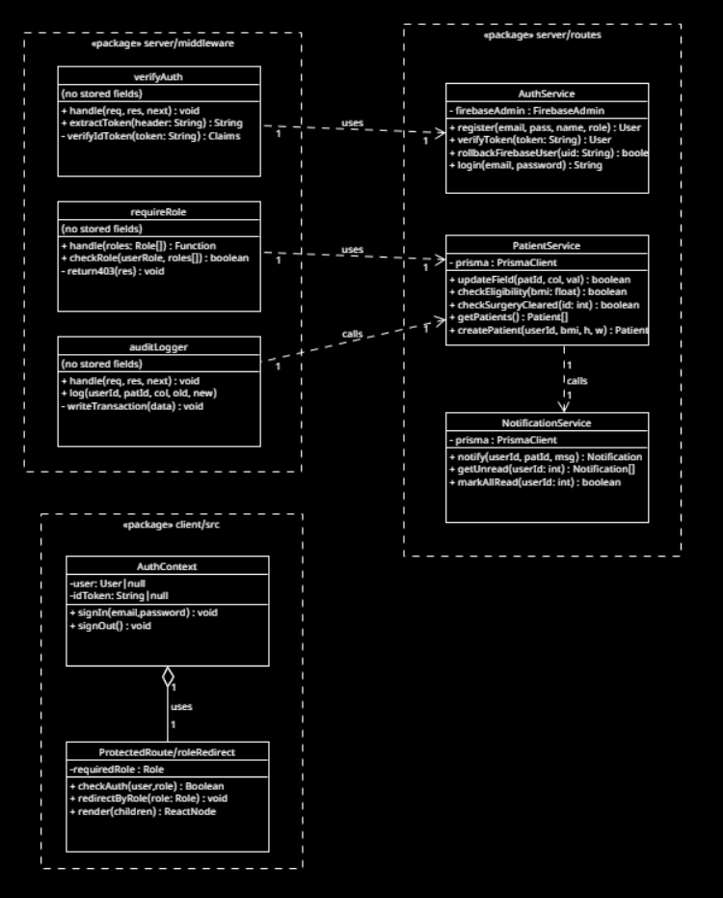

UI Design (if applicable) - Everyone

4.1 Design Approach
BariatricPath uses Bootstrap 5 as the design system. This decision was deliberate: a small student team building an MVP under tight time pressure benefits from a battle-tested, accessible, responsive component library far more than it benefits from a bespoke design language. The visual identity is intentionally clean and clinical – neutral grays, a single accent color, and high text contrast – to match the professional tone the use case demands.
All pages are built as React functional components. Shared chrome (the top navigation bar with sign-out, the toast notifications container) lives in App.jsx and is present on every authenticated page.

4.2 Page Inventory (Iteration 1)
Page | Path | Audience | Purpose
LoginPage | /login | Public | Email/password and Google sign-in.
RegisterPage | /register | Public | New user account creation.
PatientPortal | /patient | PATIENT | View own pathway status, notifications, and profile.
CoordinatorDashboard | /coordinator | COORDINATOR | List patients in caseload, update workflow fields inline.
DirectorDashboard | /director | PROGRAM_DIRECTOR | Program-level metrics and pipeline view.

4.3 Authentication UX Flow
• A user lands on /login (or is redirected there by ProtectedRoute).
• They either sign in with email/password or click "Sign in with Google".
• On success, the AuthContext receives the user object and Firebase ID token.
• A small utility (roleRedirect.js) inspects the user's role and routes them to the correct dashboard: /patient, /coordinator, or /director.
• Every protected page is wrapped in <ProtectedRoute requiredRole="...">; the wrapper checks both authentication and authorization before rendering.
• Sign-out clears the AuthContext and calls Firebase signOut(), then redirects to /login.

4.4 Notifications and Feedback
All user feedback (success messages, validation errors, network errors) is delivered via toast notifications using the react-toastify library. The team standardized on toast notifications instead of inline form errors to keep the UI uncluttered and to provide a consistent feedback channel across pages.

4.5 Accessibility Considerations
• All form inputs have associated <label> elements with explicit htmlFor.
• Bootstrap's components ship with reasonable ARIA attributes; we do not override them.
• Color is never the only signal — required fields show an asterisk; errors show both color and a text message.
• Sign-in buttons (including the Google sign-in button) have descriptive text and meet contrast requirements.

4.6 Coordinator Dashboard - Kolya
The coordinator dashboard currently has two main features: the search bar and the patient table.

The search bar is at the top of the page and supports live search by name, date of birth, or MRN. It is debounced — the search fires 300ms after the user stops typing, so no submit button is needed. Next to the search input are two dropdown menus to filter by specialist type and insurance status. The specialist filter options are: Not Eligible, Obesity Medicine Specialist, Endoscopic Obesity Specialist, and Bariatric Surgeon. While data is loading, a loading indicator is shown. If the API call fails, a red error alert is displayed. If no patients match the active filters, a contextual message is shown ("No patients match your filters." vs. "No patients found." when no filters are applied).

Below the search bar is the patient list table, which displays all patients when the coordinator logs in. Each row shows the MRN, name, BMI, specialist type, insurance status, and checklist progress. Specialist and insurance values are displayed as colored badges. For specialist type: Not Eligible is gray, Obesity Medicine Specialist is blue, Endoscopic Obesity Specialist is yellow, and Bariatric Surgeon is red. For insurance status: clear is green, not clear is red, and self pay is yellow.

Progress is displayed as a bar accompanied by a completed/total (pct%) label. The color reflects how far along the checklist is: below 40% is red, 40–99% is yellow, and 100% is green. If no checklist items exist for a patient, the bar is hidden and "N/A" is shown instead.

Database Design (if applicable) - Kolya

For our database, we decided to use PostgreSQL hosted on Supabase. We use the Prisma Object Relational Mapper to interface with the database in development instead of writing SQL directly.

Our schema has four entities: User, Patient, AuditLog, and Notification. The Role type is defined as a database-level enum with three values: PATIENT, COORDINATOR, and PROGRAM_DIRECTOR. These roles affect the permissions given to each user in the system.

The User model stores a name, email, and role, along with a firebaseUid for Firebase-based authentication and a createdAt timestamp. Each user can be associated with many audit log entries.

The Patient model is the most extensive. It includes attributes for MRN (unique), name, date of birth, BMI, and visit type, as well as one attribute for each item on the pre-surgery checklist (insurance, consult, labs, hematology, nephrology, dietitian, psychologist, previous surgery, endoscopy, barium, cardiology, colonoscopy, and sleep study). All checklist fields have schema-level defaults (e.g., "not required", "not complete") so new patients are always in a valid state. Each patient can have many associated audit logs and notifications.

The AuditLog entity is a history table that records every change made to a patient record. Each entry captures which column changed, the old value, the new value, and a timestamp. It references both the Patient and the User who made the change, with both foreign keys being nullable so that log entries are preserved even if a patient or user is deleted.

The Notification entity stores messages to be sent to patients. Each notification records the message content, a boolean isRead flag indicating whether the notification has been read, a createdAt timestamp, and a reference to the patient it belongs to.
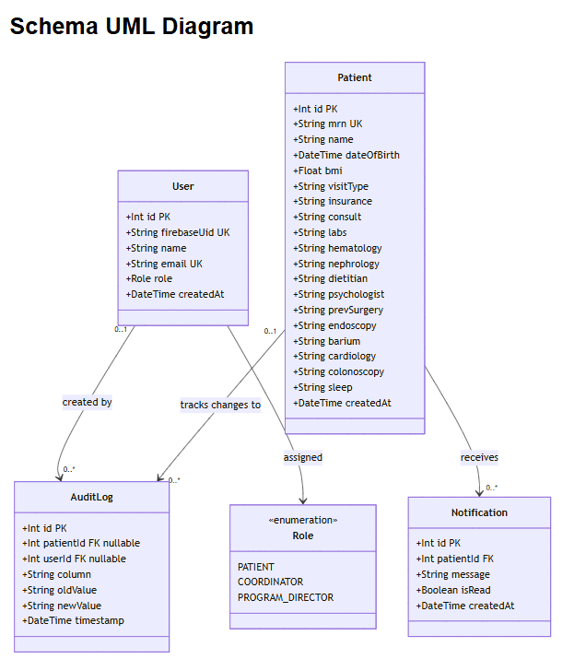

Security Design - Fatimah

6.1 Security Goals
The security design of BariatricPath is organized around the CIA triad and the IAAA model:
• Confidentiality — patient records and audit logs are visible only to authorized users acting in authorized roles.
• Integrity — the patient record cannot be modified except through the application, and every modification is recorded permanently in the audit log.
• Availability — the system stays responsive under expected demo load (out of scope to harden further in this academic project).
• Identification, Authentication, Authorization, Accountability — every actor has an identity (Firebase UID), proves it (Firebase ID token), is authorized for each action (RBAC + ownership checks), and leaves an audit trail (AuditLog).

6.2 Threat Model — STRIDE Analysis of the Login Flow
The login flow is the highest-value security target in the system. If an attacker can either impersonate a legitimate user or obtain an arbitrary user's session, every downstream control becomes moot. The following table applies the STRIDE threat model to the login flow shown in Figure 3.
STRIDE category | Threat in our context | Mitigation in our design
Spoofing | An attacker tries to impersonate a user by submitting forged credentials or a forged token. | Firebase authenticates with scrypt-hashed passwords; ID tokens are signed JWTs whose signature, expiry, audience, and issuer are verified server-side by firebase-admin on every protected request.
Tampering | An attacker modifies a request mid-flight to escalate privileges or change which patient is being acted on. | All traffic is HTTPS. The bearer token is signed and cannot be modified without invalidating the signature. Inputs are validated by express-validator before any business logic runs.
Repudiation | A user denies having made a change to a patient record. | Every state-changing action writes an AuditLog row with the actor's userId, the patientId, the column, the old and new values, and a server-generated timestamp.
Information Disclosure | An attacker reads patient data they should not see — including through the IDOR pattern where they request a record they do not own. | Two-layer defense: requireRole enforces role-based access at the route level; the in-progress ownership check (Gap 1 below) enforces object-level access by comparing the requesting user's identity to the resource's owner.
Denial of Service | An attacker floods the system with requests or login attempts. | Out of full scope for this iteration. Firebase Authentication rate-limits sign-in attempts per IP and per account. Backend rate-limiting middleware is on the Iteration 2 backlog.
Elevation of Privilege | A legitimate user tries to invoke an endpoint they are not authorized for, e.g., a patient calling a coordinator-only endpoint. | Defense in depth: ProtectedRoute on the client hides the UI, requireRole on the server returns 403 if the role check fails. The client check is for UX only; the server check is authoritative.

6.3 Login Sequence Diagram
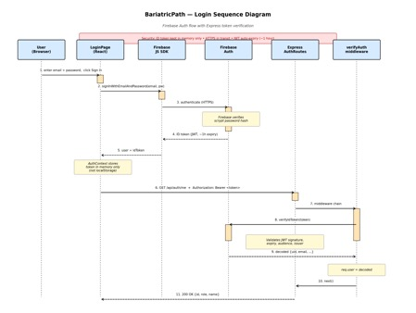
. Login sequence showing the full Firebase authentication flow, the token verification handshake on the backend, and the request-handling chain through verifyAuth middleware. The security callout at the top highlights the three key controls — in-memory token storage, HTTPS in transit, and JWT auto-expiry.

6.4 Authentication Design

Identity provider — Firebase Authentication
Firebase is the identity provider for BariatricPath. It owns:
• Password storage (hashed with scrypt with per-user salts).
• Federated sign-in (Google OAuth).
• Issuance of ID tokens (signed JWTs, RS256, ~1-hour expiry, automatic refresh).
• Account-lockout and per-IP rate limiting on sign-in attempts.

Token verification — firebase-admin
Every protected request carries an Authorization: Bearer <ID token> header. The verifyAuth middleware verifies this token on every request:
const decoded = await admin.auth().verifyIdToken(token);
This call validates the JWT signature against Google's public keys (cached and rotated), checks expiry, audience, and issuer, and returns the decoded claims (uid, email, etc.) on success — or throws on any failure. The middleware then looks up the local User row by firebaseUid and attaches { user } to the request object for downstream handlers.

Why not roll our own JWT and bcrypt?
Design decision: no jsonwebtoken, no bcryptjs
Many tutorials and starter projects use jsonwebtoken + bcryptjs to build authentication. We deliberately chose not to. Firebase already issues JWTs and already hashes passwords (with scrypt, which is stronger than bcrypt). Adding our own JWT system on top would mean two parallel session systems, two attack surfaces, two sets of bugs to find, and two places to invalidate sessions. This is a KISS violation we declined to make. The tutorials suggesting jsonwebtoken+bcrypt assume no Firebase; our architecture is different.

6.5 Authorization Design

Role-Based Access Control (RBAC)
Three roles are defined as a Prisma enum: PATIENT, COORDINATOR, PROGRAM_DIRECTOR. A factory middleware enforces them at the route level:
// example usage in a route definition
router.get('/api/admin/users', verifyAuth, requireRole('PROGRAM_DIRECTOR'), handler);
requireRole returns 403 Forbidden if the user's role is not in the allowed list. On the client, the equivalent check happens in ProtectedRoute, which hides the UI entirely from unauthorized users. The client check is for UX only — the server check is the security boundary.

Object-Level Access Control
Gap 1 (in-flight) — Object-level access / IDOR
Identified during Iteration 1 Week 2: the requireRole check confirms that the requester is a patient, but does NOT confirm that the requested record belongs to them. Without an ownership check, patient #5 could request patient #7's record by URL manipulation. This is the Insecure Direct Object Reference (IDOR) pattern. As Security Lead, the response is (a) add an 'ownership check present?' line item to the PR review checklist, and (b) review every PR that touches patient-data routes specifically for this. The fix itself is being written by the engineers building the patient routes to avoid merge conflicts.

6.6 Audit Logging
Every state-changing operation on a Patient record writes an AuditLog row. The logged fields are: userId (actor), patientId (subject), column (which field changed), oldValue, newValue, and timestamp (server clock). The log is append-only by convention: the application surface exposes only a create operation, never update or delete
In Iteration 1, audit writes are inline in the route handlers. In Iteration 2, this will be refactored into an AuditService module so that the audit-write becomes a single function call, easier to test and easier to keep consistent across routes.

6.7 Input Validation
All HTTP request bodies are validated by express-validator before they reach business logic. Validation rules are declared as middleware arrays attached to each route. Validation failures produce a 400 response with a list of field-level error messages. This protects against:
• Malformed payloads (missing fields, wrong types).
• Injection through unexpected characters in string fields.
• Out-of-range numeric values (BMI, dates).

6.8 Secrets Management
Secret | Where it lives | How it is protected
Firebase service account JSON | Local file referenced by server/.env | Listed in server/.gitignore; never committed; never copied into Docker images.
PostgreSQL password | server/.env (DATABASE_URL) | server/.env in .gitignore; .env.example committed without real values; least-privilege DB user (bariatric_user) created instead of using postgres superuser.
Firebase web SDK config | client/.env | Although the Firebase web config is not strictly secret (it is shipped to the browser), the file is still kept out of git to make leakage of secrets harder in general.
Service account in containers | Mounted into the backend container at runtime | Never copied via Dockerfile COPY; .dockerignore excludes it from the build context.

6.9 Encryption
• In transit: HTTPS in production (planned for Iteration 2/3 deployment). All third-party endpoints (Firebase, Google Sign-In) are already TLS.
• At rest: managed PostgreSQL providers (the planned Digital Ocean deployment) handle disk encryption. We document this as a platform-level control rather than implementing application-level field encryption, since field-level encryption would prevent search and reporting and the project does not require defense against an attacker who has compromised the database host.
• Password hashing: scrypt with per-user salts, handled by Firebase. Not implemented in our codebase by design (Section 6.4).

6.10 Privacy Policy, Disclaimer, Consent
Gap 2 (scheduled for Iteration 2) — Privacy Policy, Disclaimer, Consent
BariatricPath does not currently display a privacy policy, medical disclaimer, or consent checkbox. For an academic project handling synthetic patient data this is acceptable, but it is on the Iteration 2 backlog. Planned deliverables: (1) a /privacy page describing what data we collect and how we use it; (2) a medical disclaimer banner stating that this is an educational project and not medical advice, and that users should consult a healthcare provider; (3) a consent checkbox on RegisterPage that must be ticked before account creation. Estimated effort: 4–6 hours. Owner: Fatimah Hassan, scheduled by the Team Lead.

6.11 Security Decisions Log
Decision | Date | Rationale | Trade-off accepted
Use Firebase Authentication; do not implement custom JWT or bcrypt | Iter 0 | Firebase already issues JWTs and hashes passwords with scrypt; adding our own duplicates complexity. | Vendor lock-in to Firebase Auth; migration would be moderate effort if needed.
Store ID token in JS memory, not localStorage | Iter 1, Wk 2 | XSS exfiltration risk for tokens in localStorage is real and well-documented. | Token is lost on full page reload; user must sign in again. Acceptable for clinical context.
No passwordHash column on User | Iter 0 | Firebase owns credentials; storing them locally would be duplication and risk. | Cannot migrate users away from Firebase without orchestrating a password reset flow.
AuditLog is append-only by application convention, not by database trigger | Iter 1 | Simpler to reason about; matches the application's actual privilege model. | A direct-DB attacker could in principle modify the log. Acceptable for academic projects; would tighten in production with a DB-level trigger.
RBAC roles defined as a Prisma enum | Iter 0 | Type safety; impossible to assign an invalid role through the application. | Adding a new role requires a migration. Acceptable — roles change rarely.
Author-chosen PR reviewer based on what the change touches | Iter 1, Wk 2 | Security Lead reviews auth/data PRs; Design Lead reviews architecture; QA reviews tests. | Relies on authors picking correctly; mitigated by review checklist.
Object-level ownership check NOT written by Security Lead | Iter 1, Wk 2 | Avoid merge conflicts with engineers' in-flight patient routes; Security Lead reviews instead. | Slightly slower fix; offset by avoiding the chaos of conflicting branches.

6.12 Security Posture Summary
Area | Status | Notes
Authentication | Strong | Firebase Auth + server-side token verification on every protected request.
Session management | Good | JWT auto-expiry; optional server-side revoke on logout pending.
Role-based access (RBAC) | Done | requireRole middleware + ProtectedRoute on the client.
Input validation | Done | express-validator on all routes.
Audit logging | Done | AuditLog table; append-only by convention; refactor to AuditService in Iter 2.
Secrets management | Done | .gitignore, .env, .dockerignore, least-privilege DB user.
Encryption in transit | Done | HTTPS in production.
Encryption at rest | Platform | Managed Postgres handles disk encryption; documented as a platform control.
Privacy Policy / Disclaimer / Consent | Gap 1 (scheduled) | Owned by Fatimah, scheduled for Iter 2.
STRIDE threat model — login flow | Done | Section 6.2.
STRIDE threat model — patient routes | Planned | Iter 2 deliverable.
DAST scan (OWASP ZAP) | Planned | Iter 2 deliverable.

Business Logic and/or Key Algorithms - Everyone

7.1 Overview
BariatricPath does not contain heavy algorithmic work, most operations are CRUD-style updates to a patient record. The few non-trivial flows are: (1) user registration with a transactional create across Firebase and PostgreSQL, (2) login token verification, and (3) the audit-log-on-update pattern.

7.2 User Registration — Transactional Create
The registration flow must create two records: a Firebase identity record and a local User row and these two creates must succeed together or fail together. If only the Firebase record is created, we end up with a user who can sign in but has no local profile or role. If only the local record is created, we end up with orphan data.
Algorithm (POST /api/auth/register):
1. Validate the request body with express-validator (email format, password complexity, role is a valid Role enum value).
2. Call firebase-admin.auth().createUser({ email, password, displayName: name }) to create the Firebase record. On failure, return 400 with the Firebase error.
3. In a Prisma transaction, create the User row with the firebaseUid returned by Firebase. On failure, call firebase-admin.auth().deleteUser(firebaseUid) to roll back the Firebase create.
4. Return 201 with the new user's id and role (never the token; the client signs in normally to obtain one).

7.3 Login Token Verification — verifyAuth Middleware
This is the most-executed code path in the system: it runs on every protected request. The algorithm is:
1. Extract the Authorization header. If absent, return 401.
2. Parse out the bearer token. If the format is wrong, return 401.
3. Call admin.auth().verifyIdToken(token). On any error (signature, expiry, audience, issuer), return 401.
4. Look up the local User by decoded.uid (firebaseUid). If not found, return 401 (the Firebase user exists but the local user does not — a state we treat as unauthenticated).
5. Attach { user } to req and call next().
See Section 6.3 (Figure 3) for the sequence diagram of this flow including the full client-side context.

7.4 Audit-Log-on-Update Pattern
Every update to a patient field must write a single AuditLog row capturing what changed. The pattern is:
// pseudocode
async function updatePatientField(req, patientId, column, newValue) {
const before = await prisma.patient.findUnique({ where: { id: patientId } });
const oldValue = before[column];
await prisma.$transaction([ // both in one DB transaction
prisma.patient.update({ where: { id: patientId }, data: { [column]: newValue } }),
prisma.auditLog.create({
data: { patientId, userId: req.user.id, column, oldValue, newValue }
})
]);
}
The transaction is essential: the patient update and the audit log must either both succeed or both fail. Otherwise the audit log can drift from reality.

7.5 Patient Status as a Conceptual State Machine
A patient progresses through a sequence of states in the bariatric evaluation pathway: Referred → InsuranceReview → PreAuthSubmitted → Approved or Denied → (out of scope: Cleared → Scheduled → PostOp). In the current implementation, this state is captured as free-text status fields on patients rather than enforced by code, because clinical workflows often need to capture partial or non-linear states ("insurance approved but cardiology consult missing"). A formal state-machine module is a candidate for Iteration 2 if the team wants stricter enforcement; the trade-off would be reduced flexibility for coordinators.

Design Patterns - Jianing
1. Client-Server Architecture
The system is built on a decoupled architecture separating the presentation layer from the data and business logic layers.
- Client: A React Single Page Application (SPA) responsible for UI and user interaction.
- Server: A Node.js/Express RESTful API responsible for secure data transactions, email processing, and database communication.
2. Model-View-Controller Paradigm
While modern JavaScript frameworks blur strict MVC lines, the project heavily borrows from it:
- Model (Data Layer): Managed entirely by the Prisma ORM (schema.prisma). It defines relationships between User, Patient, AuditLog, and Notification entities.
- View (Presentation Layer): React components (client/src/pages/*) render the state of the data to the user.
- Controller (Logic Layer): Express route handlers (server/routes/*) receive client requests, orchestrate updates via Prisma, and return HTTP responses.
3. Provider / Context Pattern
Location: client/src/context/AuthContext.jsx Instead of passing authentication state and user roles down through dozens of nested components ("prop drilling"), the application uses React's Context API. The AuthProvider wraps the application, broadcasting the current Firebase User and their role globally to any component that subscribes to it.
4. Singleton Pattern
Location: server/routes/patients.js & client/src/config/firebase.js The application strictly manages heavy resources to avoid memory leaks:
- PrismaClient: Instantiated once and reused to maintain a single efficient database connection pool.
- Nodemailer: The email transporter is instantiated globally at the top of the route file rather than inside the POST request, ensuring only one active SMTP connection manager exists.
5. Decorator / Proxy Pattern
Location: client/src/components/ProtectedRoute.jsx The ProtectedRoute component acts as a Proxy or Decorator around standard React Router components. Before a user can view sensitive pages (like the Patient Portal or Dashboard), this component intercepts the render cycle, verifies the user's authentication token, validates their Role Array (e.g., ['PATIENT']), and redirects them to /login if they are unauthorized.
6. Facade Pattern
Location: client/src/utils/api.js The apiRequest utility function acts as a Facade over the native JavaScript fetch API. It hides the immense complexity of:
- Reaching into the Firebase instance to dynamically fetch fresh Auth Tokens.
- Injecting Authorization: Bearer headers.
- Automatically injecting the dynamic VITE_API_URL environment variables.
- Standardizing error handling. This allows the rest of the application to simply call apiRequest('/patients/123') without knowing how the underlying authentication works.
7. Strategy / Encapsulation Pattern
Location: server/utils/routingLogic.js Rather than hardcoding the complex BMI logic directly inside the Express route handler, the logic for determining a patient's specialist path is extracted into an independent getSpecialistRecommendation function. This encapsulates the business rules, making the logic easily unit-testable (as seen in routingLogic.test.js) and allows the backend routing strategy to change without affecting the API layer.

Rest APIs - Shaima

1.BariatricPath Backend API
This is a custom REST API built with Node.js and Express, running on port 5001. It follows REST conventions. Each URL represents a resource, and HTTP methods (GET, POST, PATCH) indicate the action. All endpoints are prefixed with /api.

Authentication Routes /api/auth

Authentication Routes /api/auth
Method | Endpoint | Status | Description
POST | /api/auth/register | Implemented | Creates a new patient account. Accepts name and Firebase idToken. Verifies the token, then creates a User record with the role PATIENT
POST | /api/auth/login | Implemented | Verifies Firebase idToken, looks up the user in the database, returns id, name, email, and role. Fronted uses the role to redirect to the correct portal.
GET | /api/auth/me | Implemented | Returns the currently logged in user’s details. Protected by verifyAuth. Requires a valid Firebase token in the Authorization header.

Patient Routes /api/patients

Patient Routes /api/patients
Method | Endpoint | Status | Description
GET | /api/patients | Implemented | Returns all patients. Supports ?search=(name, MRN, date of birth), ?specialistType=,?insuranceStatus=. Each patient includes a computed progress field.
GET | /api/patients/:id | Implemented | Returns a single patient by database ID. Returns 404 if not found
POST | /api/patients/recommendation | Implemented | Calculates specialist recommendation from bmi and previousSurgery. Logic: below 27→Not eligible, 27-29.9→ Obesity Medicine Specialist, 30-34.9→Endoscopic Obesity Specialist, 35+ or previous surgery → Bariatric Surgeon.
POST | /api/patients/:id/submit | Implemented | Submits the patient’s completed profile. Does three things: fetches the patient record, creates a coordinator Notification in the database, and sends a confirmation email to the patient using Nodemailer.
PATCH | /api/patients/:id/specialist | Implemented | Saves the patient's confirmed specialist choice to the visitType field in the database,
POST | /api/patients | Stub | Placeholder for creating a new patient record Not yet implemented
PATCH | /api/patients/:id/insurance | Stub | Placeholder for coordinator to update insurance status. Not yet implemented.
PATCH | /api/patients/:id/clinical | Stub | Placeholder for coordinator to update clinical checklist. Not yet implemented.

Notification Routes /api/notifications
All three routes are not yet implemented.

Notification Routes /api/notifications
Method | Endpoint | Status | Description
GET | /api/notifications/:patientId | Stub | Placeholder to retrieve all notifications for a patient
PATCH | /api/notifications/:id/read | Stub | Placeholder to mark a notification as read
POST | /api/notification | Stub | Placeholder to create a notification

Firebase Authentication API (External - Google)
- Frontend : Firebase JavaScript SDK handles user registration and login with email and password. Returns a JWT ID token after successful authentication
- Backend: Firebase Admin SDK verifyAuth middleware verifies the ID token on every protected request.

Supabase/ PostgresSQL via Prisma (External Database)
Hosted PostgreSQL database accessed through Prisma ORM. Stores four
Tables: User, Patient, AuditLog, and Notification.

Nodemailer / Gmail SMTP(External Email)
Used in POST /api/patients/:id/submit. Sends a confirmation email to the patient after they
Complete their registration, informing them of their recommended specialist and that a
coordinator will contact them within 1-2 business days. Requires EMAIL_USER and
EMAIL_PASS environment variables.

OpenAI API (External Planned, Not Yet Implemented)
The openai package is installed and OPENAI_API_KEY is in the .env. Planned for a future sprint., for the AI recommendation or patient communication in the ai-service/ folder

AI usage Log

Section | Who | AI contribution (%) | Description | Verified by
1 | Kai | 60% | AI summarized the document, I verified that the summary was correct and provided the Design Goals section | Kai
Section 2.1, 2.2, 2.3, 2.4, 2.5, 2.6 | Fatimah | [HYBRID] ~40% | AI drafted from project context; architecture diagram generated programmatically. Section owner to validate component descriptions | Fatimah
Section 3 | Kai | [HYBRID] ~40% | Section owner drafted initial classes and packages based on github code structure, AI drafted descriptions and class connections based on provided context and section owner verified | Kai
Section 4.1, 4.2, 4.3, 4.4, 4.5 | Fatimah | [HYBRID] ~20% | First-pass description of pages and UX flow. | Fatimah
Section 4.6 | Kolya | [HYBRID] 50% | I drafted the original description and revised it with AI for mistakes or details I forgot to mention. | Kolya
Section 5 | Kolya | [HYBRID] 30% | I drafted the original description and revised it with AI for mistakes or things I forgot to mention. I added the schema as context, and used it to create the UML diagram as well. | Kolya
Section 6 | Fatimah | [HYBRID] ~30% | Owned end-to-end by the Security Lead. STRIDE table, gaps, and decisions log are project-specific and written/reviewed entirely by Security Lead. | Fatimah
Section 7.1, 7.2, 7.3, 7.4, 7.5, References, Glossary | Fatimah | [HYBRID] ~20% | Pseudocode reflects real implementation patterns. | Fatimah
Section 8 | Jianing | 40% | Drafted original version and enhanced by Google Antigravity after browsing through the entire code base. AI identified and recommend several additional design patterns as well. | Kolya
Section 9 | Shaima | 40% | Used Claude to help identify REST API endpoints needed for the BariatricPathway application based on the user stories BARI-7 through BARI-16 and describe their purpose request format and response format Final API design was reviewed and modified to match the actual project schema and team implementation decisions | Kolya

References
• Firebase Authentication documentation. https://firebase.google.com/docs/auth
• firebase-admin Node.js SDK. https://firebase.google.com/docs/admin/setup
• Prisma ORM documentation. https://www.prisma.io/docs
• Express.js documentation. https://expressjs.com
• React documentation. https://react.dev
• Bootstrap 5 documentation. https://getbootstrap.com
• OWASP Top 10 — 2021. https://owasp.org/Top10/
• OWASP Insecure Direct Object Reference (IDORhttps://owasp.org/www-community/Insecure_Direct_Object_Reference
• STRIDE threat model — Microsoft Security Development Lifecycle. https://learn.microsoft.com/en-us/azure/security/develop/threat-modeling-tool-threats
• Conventional Commits 1.0.0. https://www.conventionalcommits.org
• Jacobson, I., Christerson, M., Jonsson, P., Övergaard, G. Object-Oriented Software Engineering: A Use Case Driven Approach. Addison-Wesley, 1992. (Origin of the Entity / Control / Boundary pattern.)
• Fowler, M. Patterns of Enterprise Application Architecture. Addison-Wesley, 2002. (Repository, layered architecture, Service Layer.)
• CS673 Project Description and SPPP template, Boston University Metropolitan College, Summer 2026.

Glossary

Term | Definition
BMI | Body Mass Index — clinical metric used as part of bariatric surgery eligibility.
CI/CD | Continuous Integration / Continuous Delivery (or Deployment) — automated build, test, and deploy on every change.
DAST | Dynamic Application Security Testing — security testing on a running application (e.g., OWASP ZAP).
ECB | Entity / Control / Boundary — analysis-time classification of classes from the Unified Process.
IAAA | Identification, Authentication, Authorization, Accountability — the four pillars of access management.
IDOR | Insecure Direct Object Reference — a vulnerability where an attacker can access a resource by manipulating its identifier, because no ownership check is enforced.
JWT | JSON Web Token — a signed, base64-encoded token format. Firebase ID tokens are JWTs.
KISS | Keep It Simple, Stupid — design principle favoring the simplest design that meets requirements.
MRN | Medical Record Number — the patient identifier inside a healthcare program.
MVC | Model–View–Controller — architectural pattern separating data, presentation, and control logic.
PHI | Protected Health Information — patient data subject to healthcare regulation in many jurisdictions.
RBAC | Role-Based Access Control — authorization based on the role assigned to the user.
RAG | Retrieval-Augmented Generation — pattern where retrieved documents ground a language model's answer.
SAST | Static Application Security Testing — analyzing source code for security issues without running it.
SDD | Software Design Document — this document.
scrypt | A password-based key-derivation function designed to be costly in memory; used by Firebase to hash passwords.
SPPP | Software Project Proposal and Planning — the planning document submitted earlier in the course.
SPA | Single-Page Application — a web app that loads once and updates content via JavaScript without full-page reloads.
STRIDE | Spoofing, Tampering, Repudiation, Information disclosure, Denial of service, Elevation of privilege — a threat-modeling framework.
TLS | Transport Layer Security — the protocol underlying HTTPS.

